Problem 8.10

**Identifying decision variables**: Let X,Y be the co-ordinates of the traveler with respect to X and Y axes respectively

The position of the traveler from tower 1, tower 2, tower 3 in XY plane as (x1,y1) (x2,y2) and (x3,y3) are (17,34) (12,5) and (3,23) respectively

The distance between each tower to the traveler is given as straight line

=>SQRT((x-x1)2+(y-y1)2) => SQRT((x-17)2+(y-34)2)

=> SQRT((x-x2)2+(y-y2)2) => SQRT((x-12)2+(y-5)2)

=> SQRT((x-x3)2+(y-y3)2) => SQRT((x-3)2+(y-23)2)

Hence the **objective function** is to minimize the function SQRT((x-17)2+(y-34)2)+ SQRT((x-12)2+(y-5)2)+ SQRT((x-3)2+(y-23)2)

**Identifying constraints**

The distance from the traveler to towers should be less than estimated distance, hence as per the given data, the constraints are

=> SQRT((x-17)2+(y-34)2)<=29.5

=> SQRT((x-12)2+(y-5)2)<=4

=> SQRT((x-3)2+(y-23)2)<=17.5

The output in the solver is executed as follows

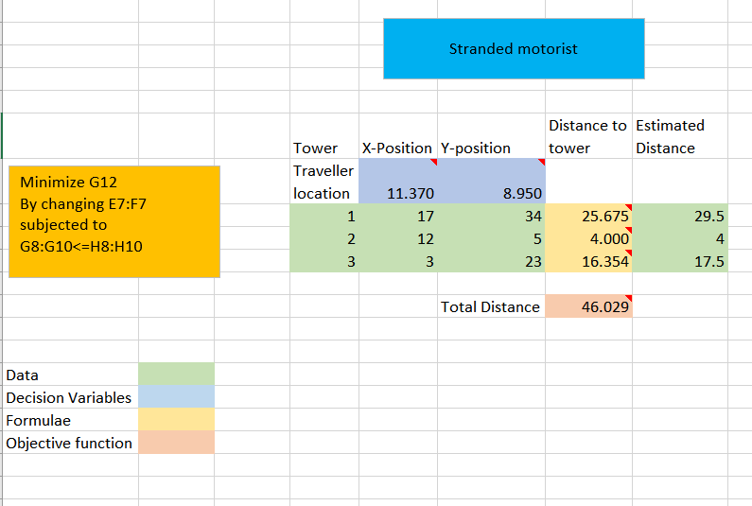

Hence the position of the traveler in (x,y) plane is estimated as (11.370,8.950)

But there is a chance of minimizing the errors so the error between the distances is calculated and the solver is directed to minimize the squared errors with constraints being (x,y)>=0.

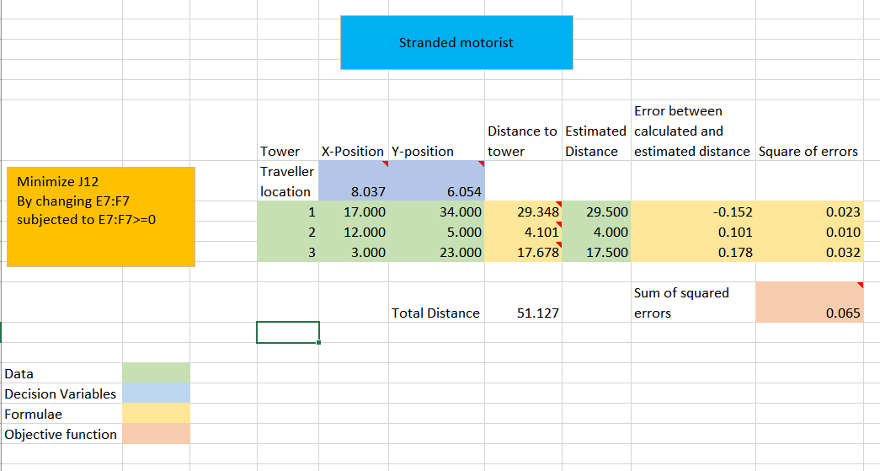

This worked and the x,y positions are further fined to precision for (8.04,6.05) to which the rescue person should look for

**Problem 8.14**

Identifying decision variables: let Q be the optimum quantity to be ordered

Given that the annual demand for the products is $15,000

Cost per unit is $0.5

Cost to place order is $10 and inventory carrying cost is 25%

For EOQ problem, the objective is to minimize the sum of purchasing cost, ordering cost and inventory cost. Hence the **objective function** is to minimize

=>(15000*0.5)+(15000/Q*10)+(Q/2*0.5*25%)

Subjected to single **constraint** Q>1

The output from the solver is executed as follows

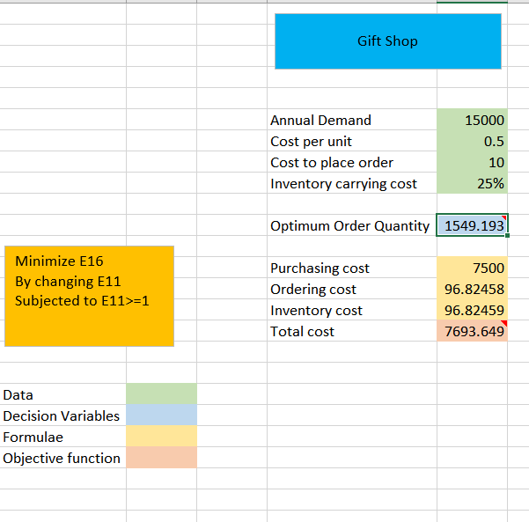

From the above, the solver solutions are

1. From the above executed solver, the optimal solution for order quantity is 1549 units
2. For the order quantity of 1549 units, the total cost is $7693.65
3. The annual order and annual inventory holding costs are 96.82 and 96.82 respectively

But since the order quantity has to be an integer, adding an integer constraint on Optimum Order Quantity, we get the following

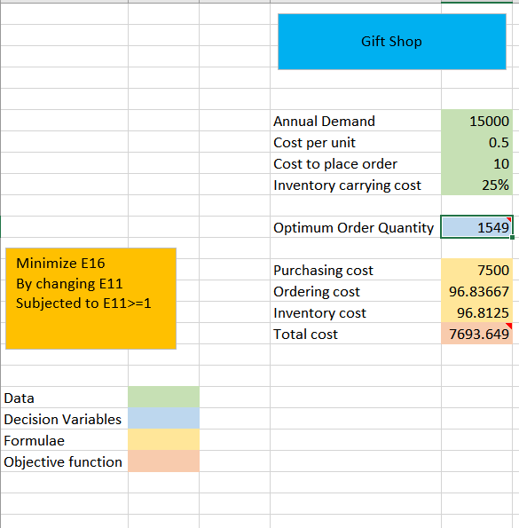

Hence, the actual solutions for the problem are as below

1. From the above executed solver, the optimal solution for order quantity is 1549 units
2. For the order quantity of 1549 units, the total cost is $7693.65
3. The annual order and annual inventory holding costs are 96.83 and 96.81respectively